National Cheng Kung University

Computer Science &

Information Engineering

2022 Student Handbook

National Cheng Kung University

Department of Computer Science and Information Engineering

Student Handbook

Table of contents
1. Purpose 2
2. Curriculum Design 3
3. Credits requirement for graduation and course selection regulation 4
4. Graduation & Bachelor/Master Continuing Program 5
5. Scholarships 6
6. Department building and regulations 7
8. Appendix 10

Purpose
Our department focus on (1) Advancing lecture quality and passing the self-evaluation in our development. (2) Improving faculty and raise the depth and width of student’s professional field. (3) Enhance teaching and research equipment to satisfy the needs of teachers and students. (4) Upgrading Department Halls to provide fine study environment.
Goals
- Teach students basic professional knowledge and life-long learning abilities.
- Teach students to use professional knowledge to solve information application problems.
- Teach student to cooperate as a team.

Core competence
  - Graduates should have basic professional mathematic and information theory knowledge.
  - Graduates should be able to derive theories and analysis and summarize experiment data.
  - Graduates should have the skill of life-learning.
2.1 Graduates should be equipped with the skill to excavate, analysis and solve information application problems.
2.2 Graduates should be able to design, innovate, test, and verify in information engineering.
2.3 Graduates should have the skill to integrate systems.
3.1 Graduates should be equipped with technological humanistic literacy and information engineering ethics.
3.2 Graduates should have good communication skills and international view.
3.3 Graduates should have active and highly motivated attitude and teamwork skills.

Curriculum Design
With a view to cultivating experts in the information engineering industry, the curriculum is designed with the following principals to take care of both the current needs and the long-term development of the industry in the future.
- Combining both theory and application classes
In order to meet the needs of the development of the information engineering industry, courses that aim to help students build fundamental theory knowledge are taught in the lower grades. On the other hand, courses concerning the skills and application of information engineering will be taught in the higher grades.
- Valuing both information technology and application
The balance between both information technology and application is pursued and most valued in the freshman and sophomore year. On the third and fourth year, students will choose from either 7 disciplines with regards to his/her interests and the development of our department. Each discipline has both technology and application featured courses. In addition, featured courses designed by graduate schools are also provided for better discipline development.
- Hands-on classes
To help students build an ideal future path, proper materials, hardware and software are provided in every course, helping students to learn effectively and to realize theories learned with hands-on classes. Students in the third year can take [project developing classes] to gain experience on researching and finishing a project independently.

The committee of teaching and courses of our department suggested these courses after rearranging courses according to the important topics of current information technology development.
- CSIE Graduate school curriculum design – apply to students enrolling after 2020
https://www.csie.ncku.edu.tw/en/news/11709
- CSIE undergraduate required credits design - apply to students enrolling after 2020
https://www.csie.ncku.edu.tw/en/news/11707
- NCKU course map -- CSIE
http://class-qry.acad.ncku.edu.tw/crm/course_map/department.php?dept=F7
- The table of courses available ( 2 years )
https://www.csie.ncku.edu.tw/en/news/10292
- The table of professors’ research fields
https://www.csie.ncku.edu.tw/en/news/9992
- The table of professors & courses in different fields
https://www.csie.ncku.edu.tw/en/news/9982
- NCKU course information & enrollment system
https://course.ncku.edu.tw/
Note : the course “Attitude brilliance and career of computer science and information engineering” is best suitable for students above freshman year.

Credits requirement for graduation and course selection regulation
- CSIE Regulations for Course Selection
- Course selection precaution and Equivalent course
https://www.csie.ncku.edu.tw/en/news/10497
- Purdue dual degree program regulations
https://www.csie.ncku.edu.tw/en/news/11004
- Special Reason Course Election Sheet (Course Select and drop sheet)
This sheet is only if the class is full, change in courses, or if it effects graduation. Part of the class will make course quota adjustments, please use the course selection system.
https://www.csie.ncku.edu.tw/en/news/12085
- Confirmation for switching classes
https://www.csie.ncku.edu.tw/en/news/9978

- General Courses (CSIE has the same regulation as NCKU’s)
- <NCKU> General Courses regulation
https://cge.ncku.edu.tw/
- <NCKU> General Courses credit regulation
https://cge.ncku.edu.tw/p/412-1007-22874.php?Lang=zh-tw

- Information Project Required course
- Recent year Project material reference
https://www.csie.ncku.edu.tw/en/education/bachelor
- Consent for project advising
https://www.csie.ncku.edu.tw/en/news/9970
- Information project release professor consent
https://www.csie.ncku.edu.tw/en/news/10665
- Graduation threshold for English
CEFR B2 level corresponding English skill test score
  - NCKU Bachelor student’s foreign language skill regulations
https://flc.ncku.edu.tw/p/412-1144-22796.php?Lang=zh-tw
Note : Feel free to contact the office of our department for regular issues.

Graduation & Bachelor/Master Continuing Program
- Information of leaving after graduation from NCKU CSIE
https://www.csie.ncku.edu.tw/en/news/9958
- Check list for graduation of undergraduates
https://www.csie.ncku.edu.tw/en/news/10646
- Application system for graduation from NCKU
http://140.116.165.83/~lou/leave/
- Bachelor/Master continuing program information and application form
https://www.csie.ncku.edu.tw/en/news/10557

Scholarships
- Scholarships related announcement
https://www.csie.ncku.edu.tw/en/news/scholarship
- NCKUEE alumni association scholarship regulation
https://www.csie.ncku.edu.tw/en/news/11951
- Prof. HONG, JHAO-KUEI scholarship regulation
https://www.csie.ncku.edu.tw/en/news/11952

6. Department building and regulations
- Entrances
- Entrances available : A, B, C and two underground parking entrances B1, B2
- Entrances closed due to epidemic : D, E, F
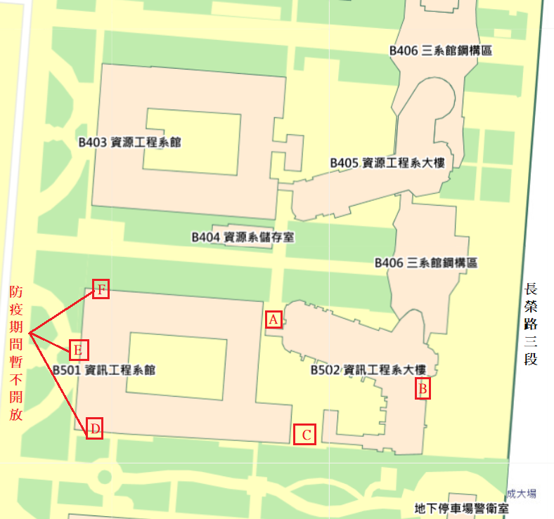

- Entrance access control
- Access control must be applied before use. Contact the document-room on the 2nd floor of the CSIE new department building.
- Please don’t lend your student ID card or access card to others.
- Please always swipe your card before entering, and don’t let anyone following enter.

- The elevators
- If the button of the floor that’s close enough to the floor you are going is pressed, please exit the elevator on that floor and take the stairs to help others get the elevator faster and to save energy.
- Please leave the handicap button to those in need.
- In case of elevator malfunctioning, please press the “Emergency call” button or grab the phone to notify the staff, stay calm and wait for the help to arrive.

- Department study center – room 65204
- Reserved for students to study.
- Please follow the study center pledge, as the following.
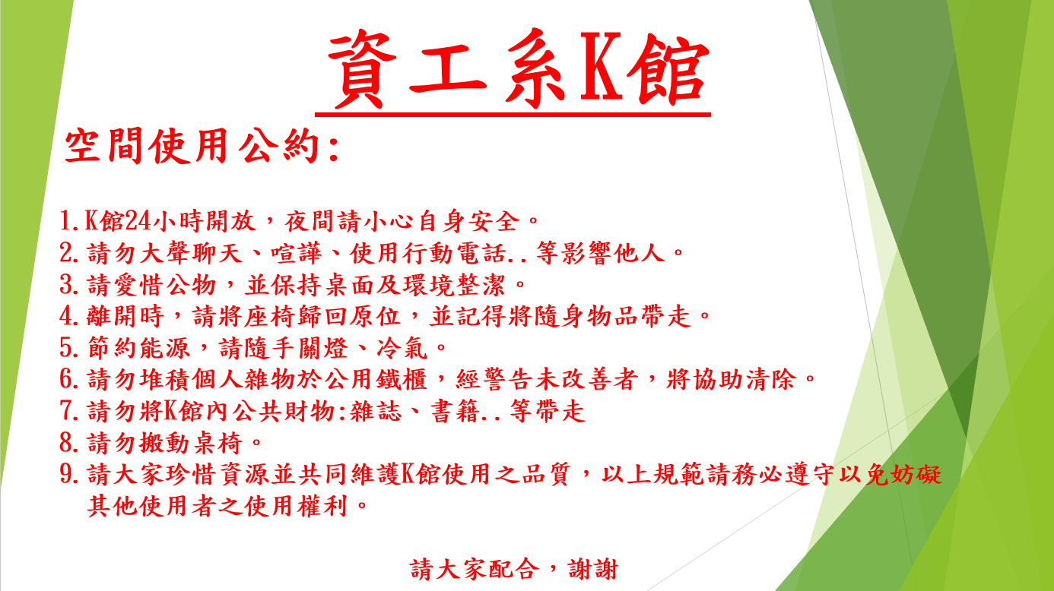

- Department’s garbage dump
- Location : Under the stairs of the old department building’s hall
- Garbage dump opening hours: Monday to Friday (7:30-16:00)
- Considerations for Trash sorting is required.
- Please do the garbage classification according to all kinds of recyclable bins, non-recyclable bins (general garbage) and kitchen waste bins.
- During the closed period of the dump, it is strictly forbidden to discard garbage at the garbage dump.
- For leftovers, please drain it before throwing it away.
- Please dispose of kitchen waste on the same day to avoid mosquitoes and odors
- Before throwing away the food waste, take out the plastic bag and sort it out
- Please sort the recyclable waste first and then wrap it properly. Please unpack the carton before throwing it away.
- Use non-dripping plastic bags when disposing of rubbish to avoid contamination of walkways and elevators
- Glass and metal fragments should be properly wrapped with multiple layers of newspaper.
- CSIE Wireless Internet:
- Name : CSIE-WLAN
Password : wificsie
- Name : CSIE-WLAN-Spa
Password : wificsie

- Safety /
- 門禁及門鎖
- 因一般門禁使用電磁力鎖，一旦斷電就會失效，最後離開實驗室的同學將門上實體鎖，並將窗戶緊閉上鎖，以防有心人士闖入。
- 節能用電
- 系上僅供研究用電，學生勿有挖礦或執行獲利之行為，違反者依法辦理。
- 實驗室內人數較少，燈光請斟酌開啟，建議不要全部打開
- 實驗室若無人在場，請將冷氣關閉，勿長時間開啟或開整夜，離開時請再次確認電源關閉。
- 教室借用
- 實驗室借用系上空間會議，請用實驗室帳號密碼登入後，選會議時段並詳細填寫個人資訊，借用時段請確實填寫，勿整天或長時間借用
- 特殊會議室須借用，請至系網頁-本系簡介-場地租借中，點選第一個檔案，下載場地申請表，填寫後送至2樓檔案室。
- 驗收相關事宜
- 請購驗收不得由學生簽章，須請職員或老師助理蓋章，
- 若實驗室沒有相關人員可進行驗收，請配合系上驗收附件相關規定執行。

8. Appendix
1. NCKU rules :
http://reg.acad.ncku.edu.tw/var/file/41/1041/img/2539/a1.pdf
See relevant regulations :
http://reg.acad.ncku.edu.tw/p/412-1041-7403.php?Lang=zh-tw
Chapter 1 General Provisions
Chapter 2 Admission
Chapter 3 Payment, Registration, Course Selection
Chapter 4 Absence, Absenteeism
Chapter 5 Transfer School or Department, Minor, Double Major
Chapter 6 Suspension, resumption, withdrawal, expulsion, and appeal
Chapter 7 Exams, Scores, Make-up Exams, repetitions
Chapter 8 Graduation
Chapter 9 Change of Name, Date of Birth
Chapter 10 Graduate Students
Chapter 11 Studying Abroad
Chapter 12 Supplementary Provisions

2. Educational related regulations
see URL: http://reg.acad.ncku.edu.tw/p/412-1041-7403.php?Lang=zh-tw
- NCKU Student Absent regulations
http://www.cc.ncku.edu.tw/rule/content.php?sn=248
- NCKU Points of Rewards and Punishments for Students
http://www.cc.ncku.edu.tw/rule/content.php?sn=249
- NCKU student behavior score regulations
http://www.cc.ncku.edu.tw/rule/content.php?sn=250
- NCKU Scholarship Review regulations
http://www.cc.ncku.edu.tw/rule/content.php?sn=251
- NCKU Ms. Ren Jiang Lusheng Scholarship for low-income student
http://www.cc.ncku.edu.tw/rule/content.php?sn=252
- NCKU Study with peace of mind relief regulations
http://www.cc.ncku.edu.tw/rule/content.php?sn=253
- NCKU Scholarship for low-income student regulations
http://www.cc.ncku.edu.tw/rule/content.php?sn=254
- NCKU Student Appeal and Appraisal Committee Setup and Appeal Handling Methods
http://www.cc.ncku.edu.tw/rule/content.php?sn=255
NCKU Student life stipend regulations http://www.cc.ncku.edu.tw/rule/content.php?sn=256
NCKU Student Work-study bursary regulations
http://www.cc.ncku.edu.tw/rule/content.php?sn=257

3.
<校>參見學生事務處網址：http://osa.ncku.edu.tw/index.php
- 國立成功大學學生請假辦法
http://www.cc.ncku.edu.tw/rule/content.php?sn=248
- 國立成功大學學生獎懲要點
http://www.cc.ncku.edu.tw/rule/content.php?sn=249
- 國立成功大學學生操行成績實施辦法
http://www.cc.ncku.edu.tw/rule/content.php?sn=250
- 國立成功大學獎學金審查辦法
http://www.cc.ncku.edu.tw/rule/content.php?sn=251
- 國立成功大學任江履昇女士清寒獎學金設置要點
http://www.cc.ncku.edu.tw/rule/content.php?sn=252
- 國立成功大學安心就學濟助辦法
http://www.cc.ncku.edu.tw/rule/content.php?sn=253
- 國立成功大學清寒學生就學獎補助要點
http://www.cc.ncku.edu.tw/rule/content.php?sn=254
- 國立成功大學學生申訴評議委員會設置與申訴處理辦法
http://www.cc.ncku.edu.tw/rule/content.php?sn=255 國立成功大學學生生活助學金作業執行要點http://www.cc.ncku.edu.tw/rule/content.php?sn=256 國立成功大學學生工讀助學金作業要點http://www.cc.ncku.edu.tw/rule/content.php?sn=257

- Academic affairs related information
Please see the URL：http://stud.adm.ncku.edu.tw/sam/index.asp#
- Outside of school rental information： http://dorm2.osa.ncku.edu.tw/
- School Loans apply system：
http://campus4.ncku.edu.tw/wwwmenu/program/stu/
- Financial resources and award and subsidy inquiry platform：
http://stud.adm.ncku.edu.tw/finance/query_ano_inteface.asp
- Rongyuan Dreams Student Aid Site：http://stud.adm.ncku.edu.tw/sgo/assistance.htm
- Scholarship Inquiry System： http://sgd.adm.ncku.edu.tw/scholarship/
- Disadvantaged Bursary application： http://stud.adm.ncku.edu.tw/dedu/

NCKU
Department of Computer Science and Information Engineering

